Uber: A Global Ride-Hailing Platform and Its Impact on Modern Transportation

Introduction to Uber
Uber is a multinational transportation network company that connects riders and drivers through a smartphone application. Founded in 2009 in San Francisco, United States, Uber has grown rapidly into one of the most recognised technology-based transportation services in the world. The company uses digital platforms to match passengers who need transport with independent drivers who use their own vehicles to provide rides.

The idea behind Uber is simple but powerful. Instead of standing on a street corner to hail a taxi or calling a taxi company, users can open the Uber® app on their smartphone, enter their destination, and request a ride. The app automatically finds a nearby driver, shows the estimated arrival time, calculates the fare, and processes payment electronically.

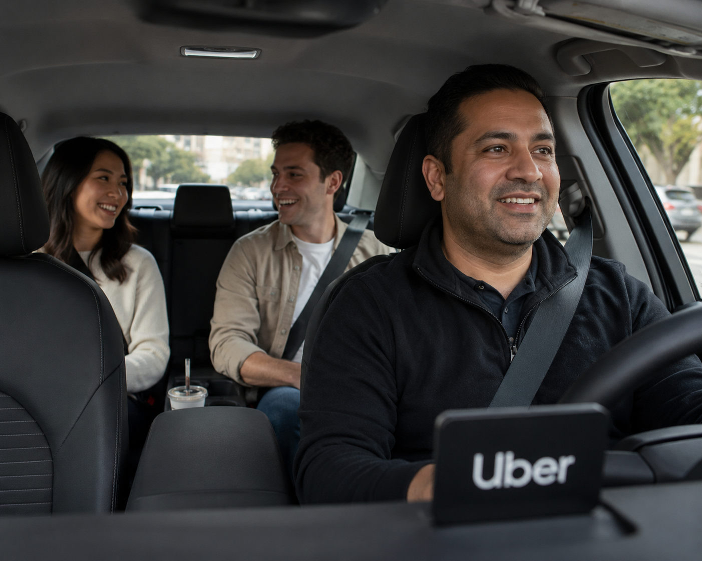
Uber is often described as part of the “gig economy” because drivers are not traditional employees but independent contractors who earn money by providing services through the app. Over the years, Uber has expanded to hundreds of cities across the globe, including many cities in South Africa. It has transformed the way people think about transportation, technology, and flexible work opportunities.

How the Uber App Works
The Uber app works using:
- GPS technology
- mobile internet connectivity
- cloud-based servers.
When a user opens the app, it detects their current location using the phone’s ^{GPS} system. The user then types in their destination, and the app calculates an estimated fare and travel time.

Once the ride is confirmed, Uber’s system searches for available drivers in the area. The closest suitable driver receives a notification on their driver app and can accept or decline the request. If accepted, the rider can see the driver’s name, vehicle details, estimated arrival time, and a map showing the driver’s movement in real time.

User opens Uber App
User enters destination
System calculates fares & finds nearby drivers
Driver accepts request
Driver picks up passengers
Trip completed & payment processed
Both driver and rider rate each other

Payment is processed electronically through a linked debit card, credit card, or digital wallet. At the end of the trip, both the rider and the driver can rate each other. This rating system helps maintain service quality and safety standards. The entire process is automated and efficient, reducing waiting times and simplifying transport arrangements.

Types of Uber Services
Uber offers a variety of services to meet different customer needs. One of the most common services is UberX, which provides affordable rides in standard vehicles. UberXL offers larger vehicles that can accommodate more passengers, making it suitable for families or groups.

UberBlack provides premium rides in luxury vehicles driven by highly rated drivers. In some cities, Uber also offers shared ride options where multiple passengers travelling in the same direction share a vehicle to reduce costs. Additionally, Uber has expanded beyond passenger transport. Uber Eats allows customers to order food from local restaurants for delivery, while Uber Connect enables package delivery services.

These service options allow Uber to serve a wide range of customers, from budget-conscious students to business professionals seeking premium travel experiences.

Uber’s Global Expansion
Since its founding in 2009, Uber has expanded to numerous countries across North America, Europe, Asia, Africa, and South America. Its rapid growth has been driven by smartphone adoption and improved internet connectivity.

In South Africa, Uber operates in major cities such as Johannesburg, Cape Town, and Durban. It has provided employment opportunities for thousands of drivers and convenient transport options for residents and tourists.

Uber adapts its services to local markets. In some countries, it offers motorcycle taxis or auto-rickshaw services. In others, it partners with local transport providers. This flexibility has helped Uber become a global brand.

The Impact of Technology on Transportation
Uber represents a significant example of how technology transforms industries. By using mobile apps, GPS tracking, digital payments, and data analytics, Uber has modernised transportation services.

Technology allows Uber to analyse traffic patterns, predict demand, and optimise routes. Artificial intelligence helps improve pricing models and match drivers efficiently. These innovations increase efficiency and reduce idle time for drivers.

Uber has also encouraged traditional taxi services to adopt similar technologies, such as app-based booking systems. As a result, consumers benefit from improved services and increased competition.

Comparison: Uber transport vs traditional taxi transport
Feature | Uber | Traditional Taxi
Booking Method | Mobile app | Phone call or street hail
Payment Method | Cashless (card/digital) | Cash or card
Fare Estimate | Shown before trip | Calculated after trip
Pricing Model | Dynamic (surge pricing) | Fixed or metered fare

Social and Economic Impact
Uber has both positive and negative social impacts. Economically, it creates income opportunities for drivers and supports related industries such as vehicle financing and insurance.

However, critics argue that gig workers do not receive the same benefits as full-time employees, such as medical aid or paid leave. This raises questions about labour rights and worker protection.

Socially, Uber increases mobility and accessibility, especially in areas with limited public transport. It can improve access to jobs, education, and healthcare services. However, concerns about traffic congestion and environmental impact remain important discussions.

The Future of Uber
Uber continues to innovate and explore new technologies. The company has invested in electric vehicles to reduce carbon emissions and support environmental sustainability.

Autonomous (self-driving) vehicle technology is another area of interest. Although still under development, self-driving cars could change the future of ride-hailing services. Uber also continues to expand its food and package delivery services.

As technology evolves, Uber is likely to remain a key player in digital transportation platforms, adapting to changing customer needs and regulatory environments.

Conclusion
Uber has transformed the global transportation industry by combining technology with everyday travel needs. From its founding in 2009 to its current international presence, Uber demonstrates how digital innovation can disrupt traditional industries.

While it offers convenience, affordability, and flexible income opportunities, it also faces challenges related to regulation, safety, and worker rights. Its continued success depends on responsible management, technological innovation, and adaptation to local laws.

